Mariam tsirekidze ID:823460489
I created 4 different class: 1)employee class. Which is base class and have all common variables and functions
2)owner class. Which is derived class and have nothing is additional here
3)waiter class. Which is derived class and have “experience” field as an
additional variable
4)chef class. Which is derived class and have “cuisine” filed as an additional variable
We know that salary is different for every employee that’s why I used accessor getSalary in order to access private data member “salary” and Calculate_Salary() to calculate salary for employees with different status.
If we have loose instead of profit. I decided to cut that money from chefs and the owner’s salary because they have 20% and 60% of the profit. If the loose is x dollars, chefs salary is 10 000 – 0.2*x and the owner’s salary is 15 000 – 0.6*x.
The user can define profit and tip.
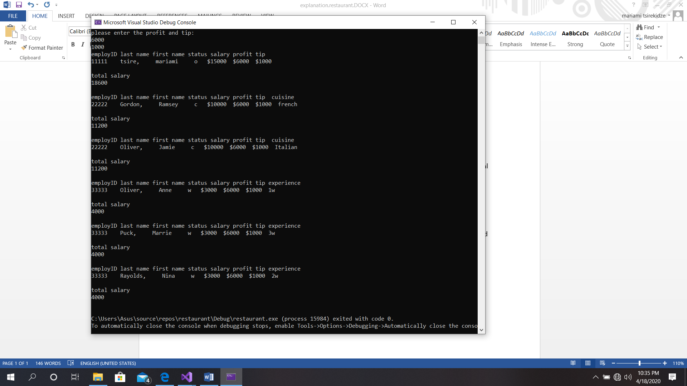
1)month 1: profit 6000 and tip: 1000

2) month 2: we have loose 6000$ and tip 300$ (so we have profit -6000$)

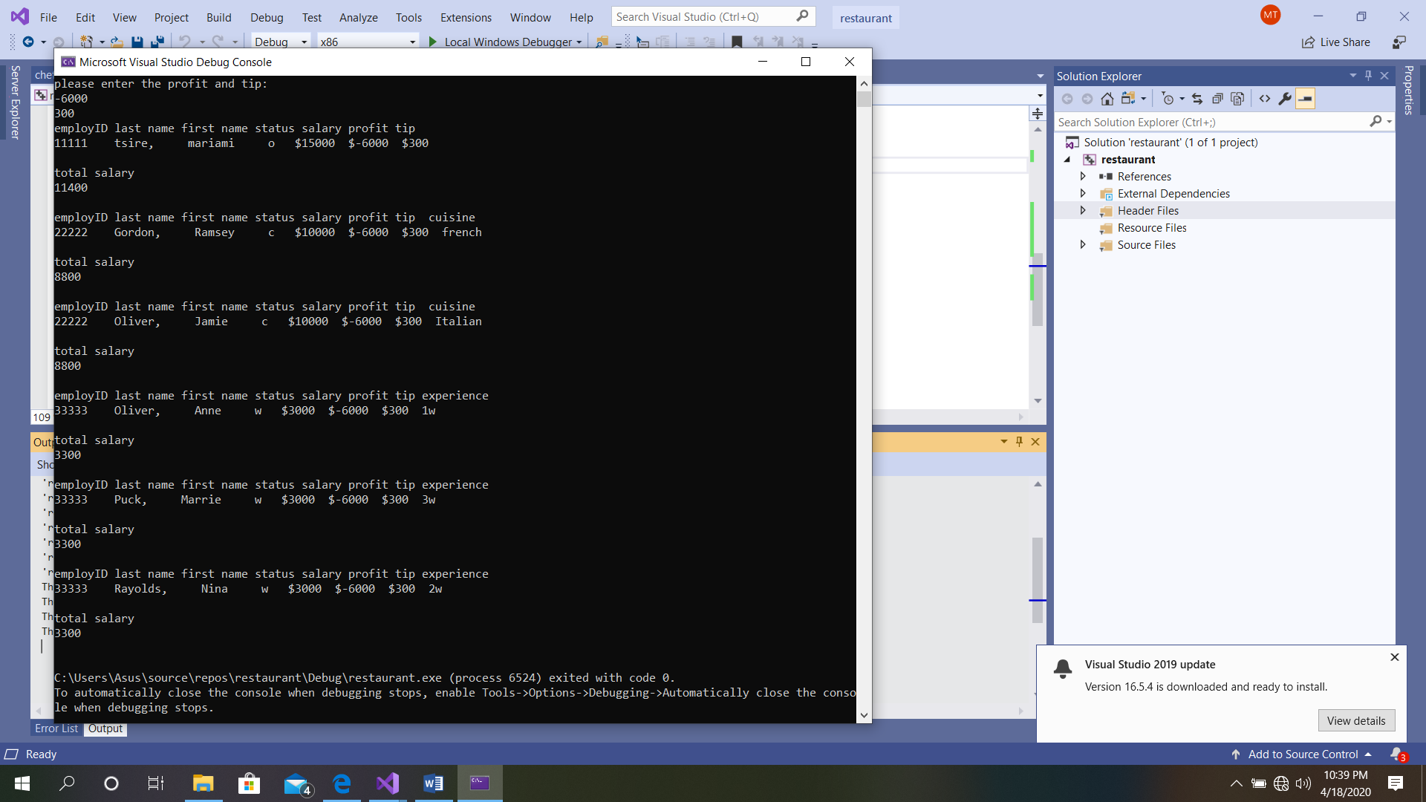

3)month 3: after a big loose owner have 0 salary, chief has 5 000 $ and waiters have same as other cases
The owner has to pay employees salaries.

